New Demand Responsive Transport
An exciting new Demand Responsive Transport (DaRT) has been introduced in parishes in the North of Essex.

This service allows residents to travel between 0600 and 2000 Monday to Saturday. It increases the opportunities to travel and improve access to shopping, health appointments, work, school or college. It can also be used to visit friends and family.
Passengers can travel alone or as a group. Concessionary Bus pass holders can use the service for free after 0900 Monday to Friday and all day on a Saturday.

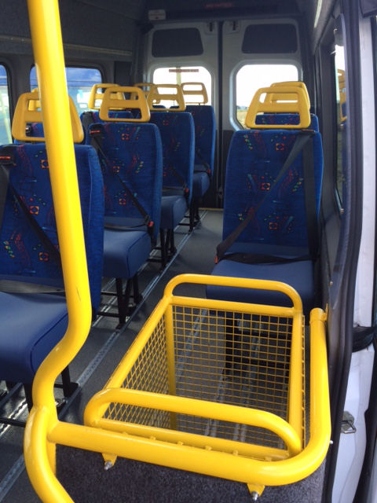
Instead of using fixed routes with fixed stops and times, customers book journeys with the operator in advance and are picked up from an agreed point – often their own home, a bus stop or local place of interest. To book the DaRT service contact Arrow Taxis on: 01621 874411.
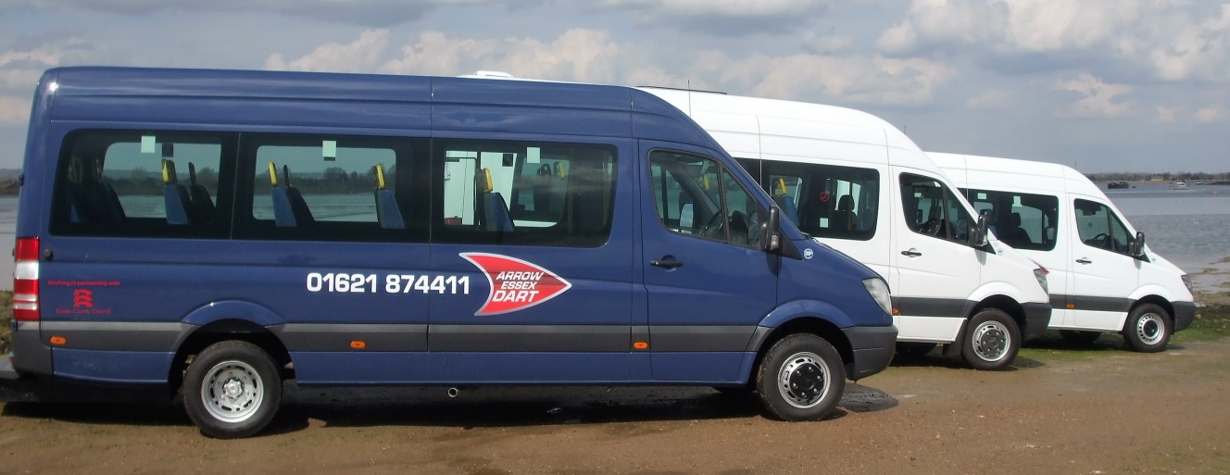

Details of New DaRT Operations in Uttlesford

DaRT 1
The fully flexible service operates within the parishes of Arkesden, Berden, Chrishall, Clavering, Elmdon, Farnham, Langley, Littlebury, Manuden, Quendon and Rickling (areas not served by service 301), Strethall, Wendens Lofts and Wicken Bonhunt.
Travel is allowed to and from anywhere within these zones, between these zones, and also direct to Saffron Walden town, Bishops Stortford town, healthcare facilities in Royston, Essex and Herts Hospital as well as the closest train stations.
Care is taken not to undermine existing bus services. Passengers will be encouraged to make connections with services 301, 7/7a, 59, 60 (formally 18) and citi 7 for onward journeys to Cambridge, Chelmsford, Haverhill, Harlow, Stansted Airport and beyond.

Map 1: Area of coverage for Demand Responsive Transport DRT1
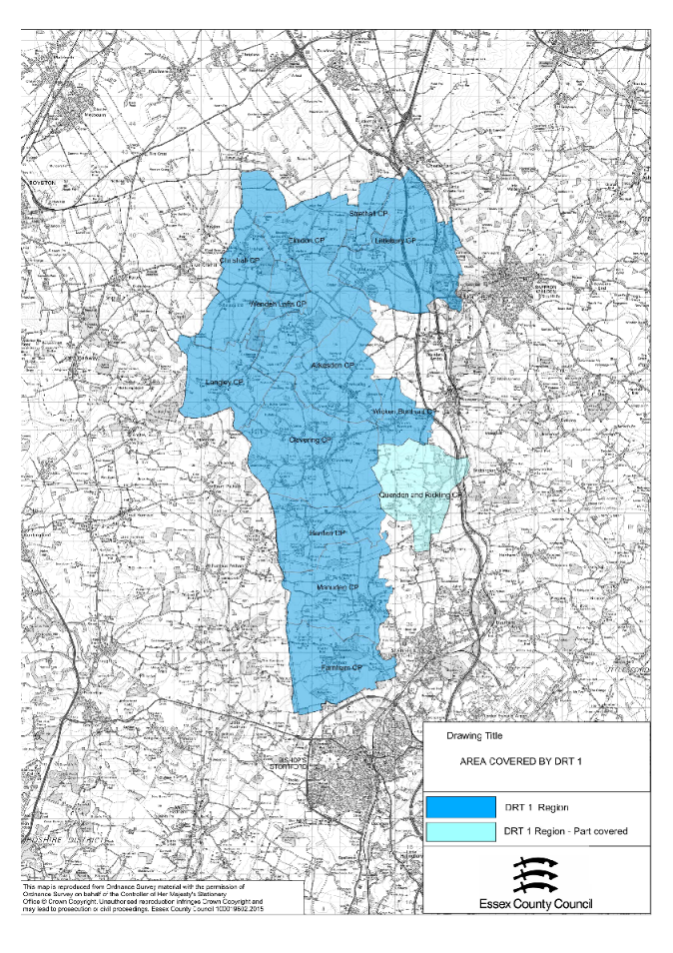

DaRT 2
The fully flexible service operates within the parishes of: Bardfield Saling, Chickney, Debden (part – to access Saffron Walden or parishes within the DRT2 areas and for residents who are unable to access service 6), Gt Bardfield (part - to access Saffron Walden or parishes within the DRT 2 area and for residents who are unable to access service 9/10), Great Easton, Great Saling, Great Sampford, Lindsell, Little Bardfield, Little Easton, Little Sampford, Radwinter, Thaxted (part – to access Great Dunmow or parishes within the DRT2 area and for residents who are unable to access service 6) , Tilty, Wimbish
Travel is allowed to and from anywhere within these zones, between these zones, and also direct to Saffron Walden, Great Dunmow and Braintree town centres, including Braintree train station, Braintree Community hospital and Braintree College.
Care is taken not to undermine existing bus services. Passengers will be encouraged to make connections with services 301, 7/7a, 59, citi 7, 42a, 60 (formally 18), 70, 352, and 133 for onward journeys to Cambridge, Chelmsford, Colchester, Halstead, Harlow, Haverhill, Stansted Airport and beyond. It will not provide transport within Braintree, to the Freeport Shopping Village or to Audley End Station, connections can be made within the towns.
Map 2: Area of coverage for Demand Responsive Transport DRT2
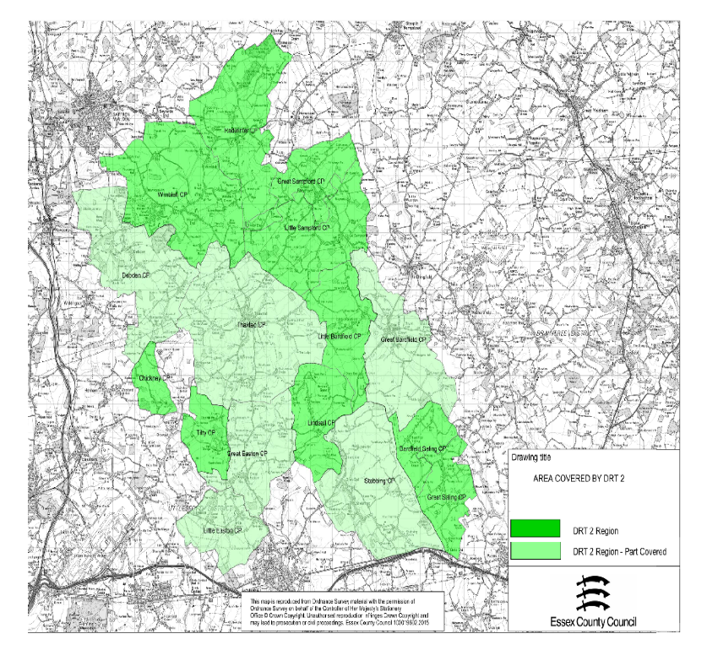

Frequently Asked Questions
When does it operate?
DaRT 1 and 2 operate between 0600 and 2000 hours, Monday to Saturday. Unlike a bus service there is no set timetable.

How do I book a journey?
Telephone Arrow Taxis Essex Ltd on 01621 874 411 and explain
- where you would like to go
- where you would like to be collected from
- what time you need to go (please give at least 2 hours notice before travelling)

The operator will also need to know:
- your name
- your telephone number
- any specific requirements, such as if you are a wheelchair user or you have difficulty walking

It is advisable to book your return journey at the same time as your initial booking otherwise you will need to give 2 hours’ notice for your return journey.

Remember to be ready when you are due to be collected.

How much will it cost?
 | Adult  (age 16 or over) |  | Child  (age 5 to age 15 inclusive)
Distance | Single | Return | Single | Return
Less than 2 miles | £2.50 | £3.50 | £1.50 | £2.00
Between 2 and 5 miles | £4.50 | £6.50 | £2.50 | £3.50
More than 5 miles | £5.50 | £8.00 | £3.00 | £4.50

Concessionary bus pass holders can travel for free after 0900 Monday to Friday and all day Saturday.

How can I pay?
Cash on the bus or by debit/credit card over the telephone.

Lost property, comments, questions or concerns
If you leave something on the bus or have any comments, questions or concerns please contact the operator directly on 01621 874 411.
What sort of vehicle will be used?
8 to 16 seat vehicles with the DaRT logo.

Can passengers take their trolleys?
Yes. There will be a cage area in the mini bus for trolleys. It is advisable to mention this when booking the service.
Can you travel by yourself?
Yes, a taxi may be used when the numbers travelling are very small.
How will hospital appointments work?
When travel is booked generally the return journey time is also booked. The passenger has the option to change it but if it is less than 2 hours’ notice needs to be flexible.
Does the DaRT mean that I can travel every day?
Yes. You can travel any time between 0600 and 2000 Monday to Saturday. You may be asked to be flexible so passengers are grouped together.
Can a relative or friend book on my behalf?
Yes.
Can people use the service to go out for social / leisure activities?
Yes. Experience has shown passengers often choose to book the service as a group and passengers who previously could not use a conventional service can use the DaRT. As long as it is safe to do so the service can pick up passengers from their homes.
Can a group of people book together?
Yes, you will need to say how many people will be traveling.

